Explore Weather Trends

Project 1 – Udacity Data Scientist Nanodegree / Kévin Péricart

**Step 1 – Data Extraction**

I first extracted all cities from the city_list table. Then, I choose Paris, the beautiful city where I live and used the SQL code below:

SELECT * FROM city_list

SELECT * FROM city_data WHERE city=’Paris’

Finally, I extracted global temperature data from the global_data table and used the SQL code below:

SELECT * FROM global_data

**Step 2 – Moving Average Calculation**

In order to compute the Moving Average, I used spreadsheet application Excel. Then I computed the 7-year Moving Average (and created an idiosyncratic column) both for Paris and the global temperature. My Excel application being a French version, I had to replace the dot “.” in the range of values by a comma “,” in order to compute the Moving Average with the function (=MOYENNE/AVERAGE).

**Step 3 – Data Visualization**

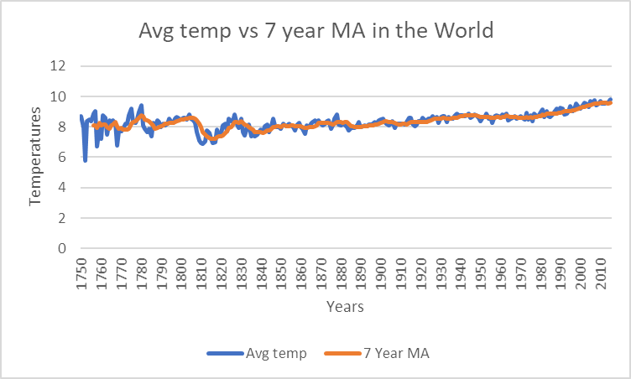I plotted both Average temperatures and Moving average for Paris and the World.

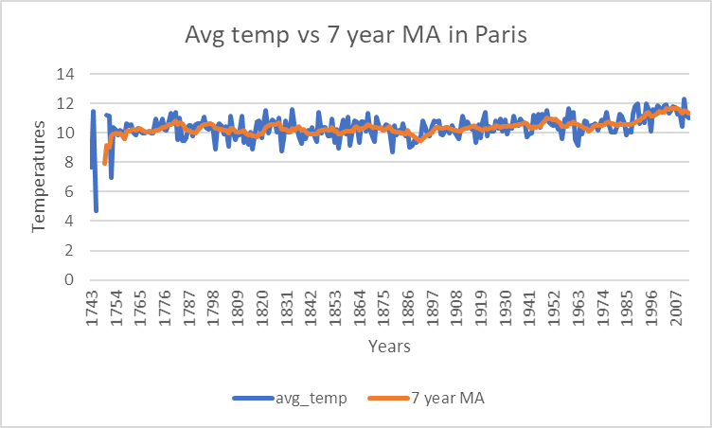

**Step 4 – Observations**

* We can see that the temperature in Paris is about 2 degrees warmer than the average temperature in the world;
* The temperature in Paris and the average temperature of the world follow the same dynamics. Indeed the moving average was about 10 degrees in Paris in 1760 while 8 degrees in the average world the same decade (a difference of +2). This difference is constant over time, at the dawn of the year 2000 the average temperature is 12 degrees in Paris and 10 degrees in the rest of the world;
* The temperature seems to stagnate from 1750 to 1900 before undergoing an acceleration due to the industrial revolution;
* Global warming is relatively unobservable before the beginning of the 20th century. Since 1900, temperatures seem to be rising continuously.